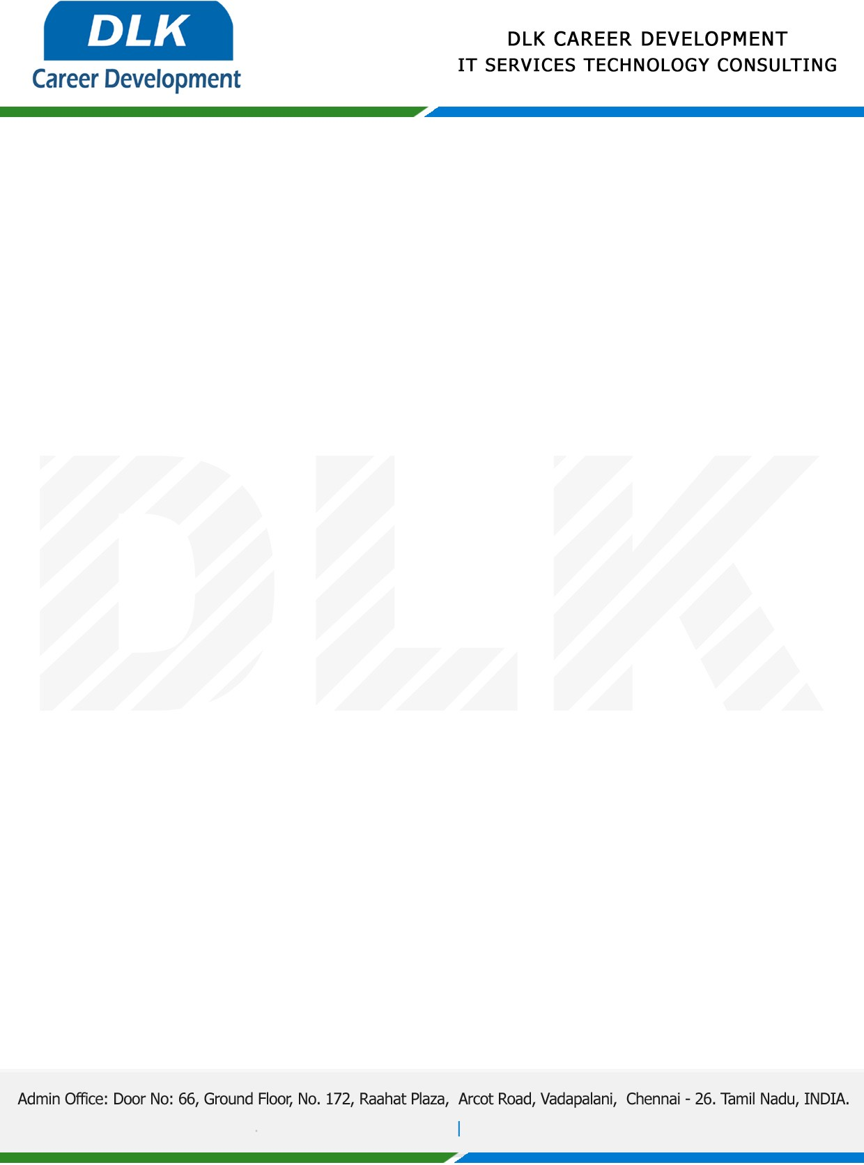

Date: 01 /December/ 2023

**To**

Department of Computer Science

Head of Department,

Pachaiyappa’s College for Men, Kanchipuram.

**Sub: Letter of Project Acceptance**

This is to certify that **MR Surya C (REG NO:** **832100046)** final year student of has accepted the Project Work duration from **December 2022 to April 2023** under the domain **“Python”.** During the Project, all information and data collected from you should be kept confidential.

**Topic**: Facial recognition for criminal detection

We appreciate your interest in **DLK CAREER DEVELOPMENT**

